ADC Instructions

Load ADC Value Test

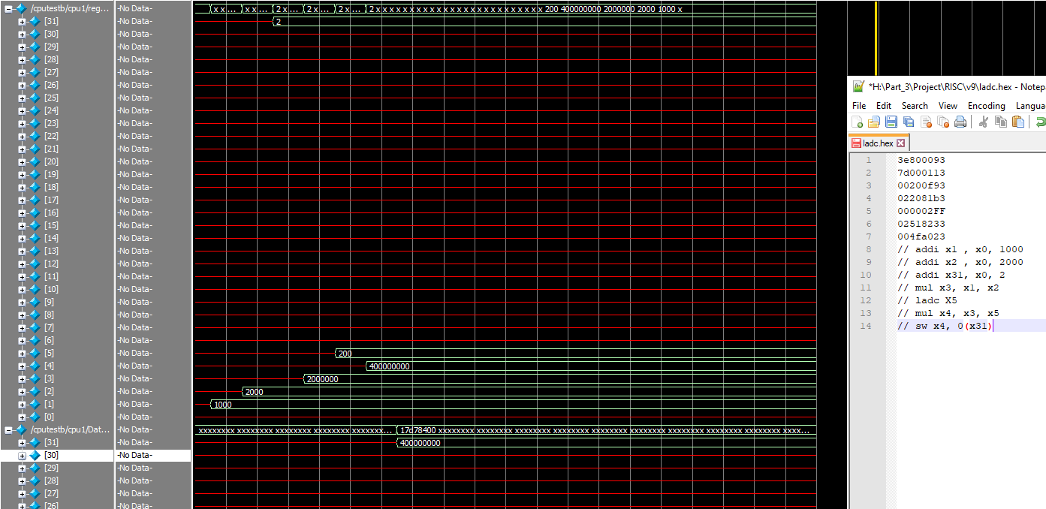Here is the output waveform showing the regs and memory, and the assembly program which is correctly working

The instruction to send the value has been created which sends the value at rs1 to the audio codec

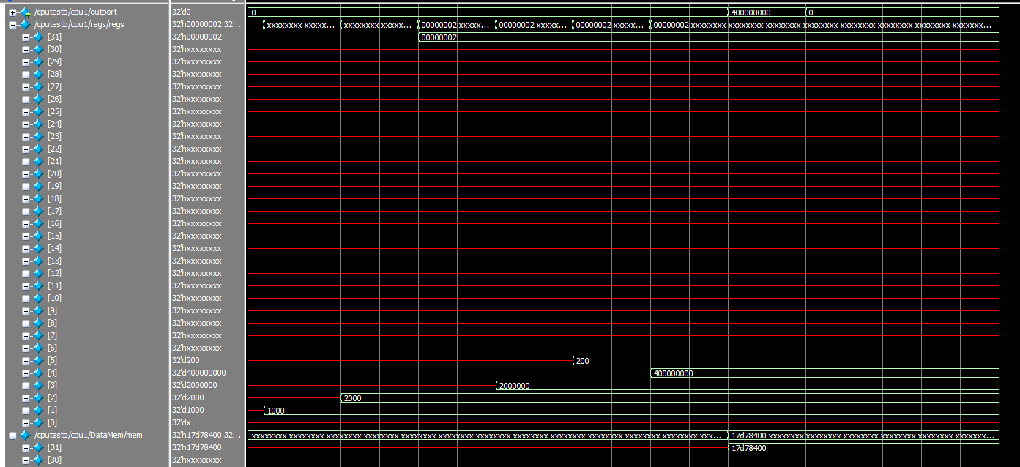

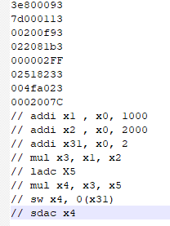

Same program as before but with added SDAC which outputs x4.